UA-WISE 2021 Election
Executive application
READ FIRST- instructions:
Answer the questions on the second page of this document
Export to a PDF file (if you don’t we will send it back to you and ask you to resubmit it)
-Under FILE click EXPORT
-Select CREATE PDF/XPS
Send to uawse@ualberta.ca by 4pm on April 9th 2021

Asynchronous voting will occur from 8am to 4pm on April 11th 2021
If you want to make a live pitch about why you should be elected, please come to our voting meeting on April 11th at 4pm.
If you can’t attend feel free to send us a power-point presentation, or other summary of what you would have pitched, and we will read it on your behalf

All executive positions are up for grabs, send us an email if you have any questions
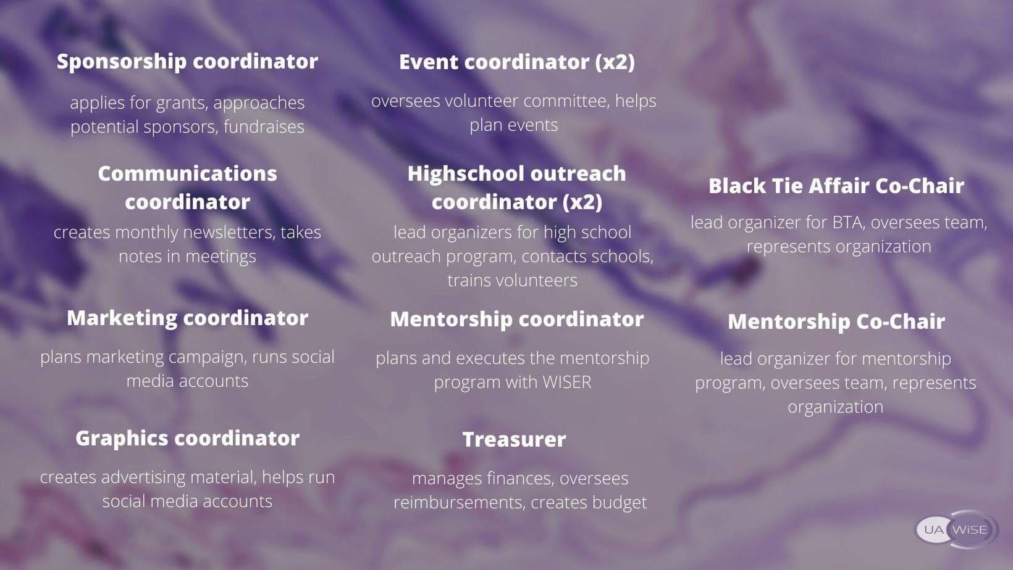

Name:
Current program:
Year:
Current/past UA-WiSE position(s) -including volunteer committee:

Top 3 executive position choices (in order):

Why do you want to join/stay in UA-WiSE?

List your top 3 skills for the position you want

What relevant experience do you have?

Tell us more about yourself! Hobbies, interests, fun facts, etc.

